## Simulations

Showing working of start, pause, reset and continue

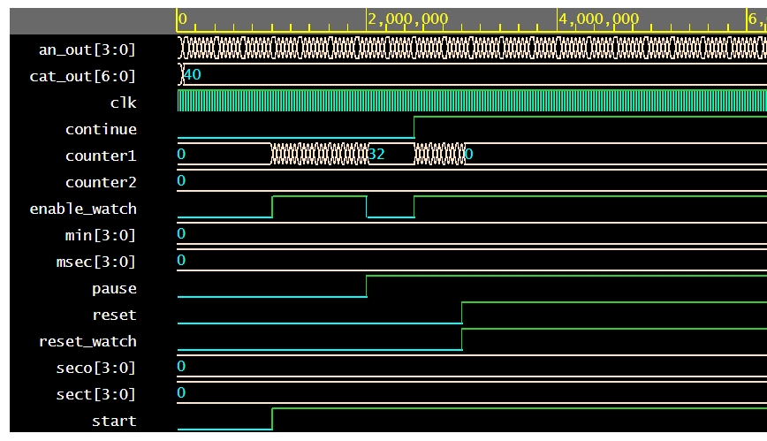

On pressing pause, the display gets stopped

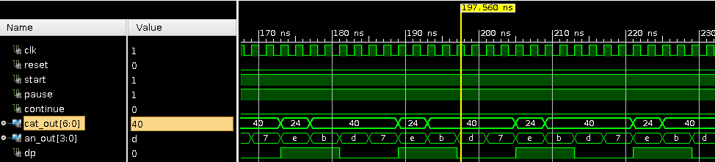

On continue, it starts again

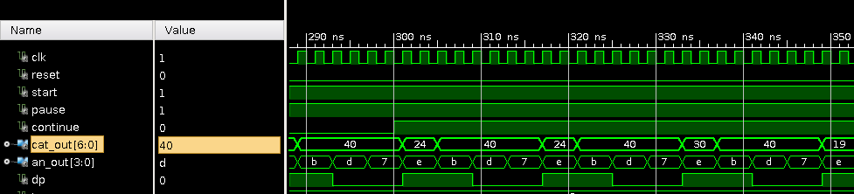

After reset is ON, cat_out goes to zero

